**PROCEDURE TO RUN WEB APPLICATION ON VIRTUAL MACHINE**

**Step 1:**

Updating the packages using - **sudo apt-get update**

**Step 2:**

Installing apache2 using - **sudo apt-get install apache2**

**Step 3:**

Typing the program in terminal using nano editor -

**sudo nano filename.html**(u.html)

**Step 4:**

Run in web browser - **localhost/filename.html** (u.html)

**Step 5:**

Pinging the result in host machine by giving the IP address – [**http://192.168.71.128/u.html**](http://192.168.71.128/u.html)

Fig 1: Program to run web application

Fig 2: Output window in ubuntu

**Fig 1:**

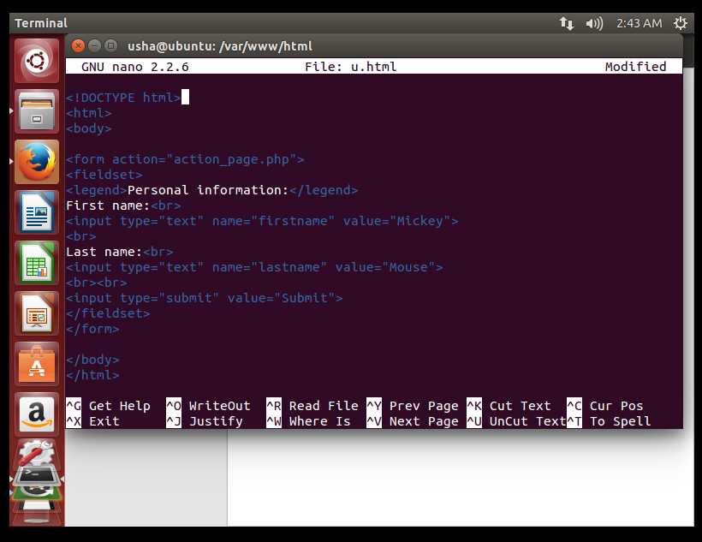

**Fig 2**:

